MEDICAL ACUPUNCTURE
Volume 00, Number 0, 2019 # Mary Ann Liebert, Inc. DOI: 10.1089/acu.2019.1373

Efficacy of Acupuncture at the Sphenopalatine Ganglion in the Treatment of Persistent Allergic Rhinitis

Jiao-Ping Mi, MD,^{1,}* Peng He, MD,^{1,}* Fang Shen, BS,¹ Xuan Yang, MD,² Miao-Feng Zhao, BS,¹ and Xin-Ye Chen, MD¹

ABSTRACT

Objective: The aim of this research was to explore the hypothesis that acupuncture at the sphenopalatine ganglion (SPG), a new a new method of acupuncture, would be more efficacious and safe than traditional acupuncture in the treatment of persistent allergic rhinitis (PAR).
Materials and Methods: For this study, 120 patients with PAR were randomly assigned to SPG acupuncture, traditional acupuncture (Yingxiang [LI 20], Hegu [LI 4], and Yintang [Ex-HN 3]), or drug treatment (bude- sonide nasal spray). Efficacy was assessed by using single symptoms, including sneezing, rhinorrhea, nasal obstruction and nasal itch, a total nasal symptoms score (TNSS), and a Rhinoconjunctivitis Quality of Life Questionnaire (RQLQ) before treatment, the day treatment ended, and 4-, 8-, 12-weeks later, respectively.
Results: Four weeks after treatment ended, the effectiveness rate in the SPG-acupuncture group was superior to that of the traditional-acupuncture group (P = 0.033) but was still lower than that of the drug-treatment group (P = 0.039), with mean effectiveness rates of 69.70%, 44.44%, and 71.43%, respectively. However, these rates gradually decreased in each group during weeks 8 through 16. Moreover, statistically significant improvements in TNSS’, and reductions in nasal congestion and sneezing symptoms were observed in the SPG-acupuncture group, compared with those in the traditional-acupuncture group as early as the day treatment ended and this continued throughout the observation period (P < 0.05). However, the improvement did not continue for sneezing, during weeks 8 through weeks 12 after treatment ended. The RQLQ of the SPG-acupuncture group was lower than that of the traditional-acupuncture group at week 12; however, there were no differences at weeks 8 and 16.
Conclusions: The data generated by this study confirmed that acupuncture at the SPG alleviated the symptoms of PAR rapidly and safely, especially nasal obstruction, and improved the patients’ life quality. These results were worthy of clinical promotion.

Keywords: allergic rhinitis, sphenopalatine ganglion, acupuncture, clinical effects, TNSS, RQLQ

INTRODUCTION

llergic rhinitis (AR), an immunoglobulin E (IgE)– mediated inflammatory disease of the nasal mucosa,
A
is estimated to have a higher prevalence of 8.7%–24.1% in 11 Chinese central cities and has substantial economic and
social impacts.¹ Persistent allergic rhinitis (PAR), charac- terized by persistent symptoms >4 days per week and >4 weeks per year, affects up to 16% of the general population in some countries.² Not surprisingly, myriad standard treatments are recommended, but existing treatment approaches—and even surgical interventions—have not

Downloaded by Kristen Sparrow from www.liebertpub.com at 01/05/20. For personal use only.

Department ¹Otolaryngology Head and Neck Surgery, and ²Traditional Chinese Medicine, The 5th Affiliated Hospital of Sun Yat- Sen University, Zhuhai, Guangdong, People’s Republic of China.
*Drs. Mi and He contributed equally to this article.

1

been able to address this tricky disease effectively. Thus, continuing efforts are ongoing to explore novel alternative strategies and targets for the management of PAR.
Downloaded by Kristen Sparrow from www.liebertpub.com at 01/05/20. For personal use only.
Acupuncture, as a complementary and alternative medi- cine therapy with advantages of safety and no side-effects, is used to target certain specific acupoints to improve the body’s microenvironment, thus playing an important role in the treatment of various diseases.³ Autonomic dysfunction has been shown to be an important factor in the induction and aggravation of AR.⁴ Numerous previous studies have demonstrated that acupuncture can alleviate the symptoms of AR effectively with lasting and stable efficacy. There- fore, acupuncture has been widely used in China, Japan, and the United States to treat this condition.^{5–7} Not surprisingly, acupuncture was included in a regimen for treating AR for the first time in the United States’ guideline for treating allergic rhinitis (2015 edition)⁸ and confirmed in the latest guidelines in China (2018 edition).⁹ Moreover, acupuncture might also exert its anti-inflammatory actions to prevent or reduce the development of AR via multiple neuroendocrine and immune network pathways.¹⁰ Further research has revealed that this acupuncture-induced modulation of nasal mucosa immune function might relate to a reduction in the excessive release of neuropeptide substance P and specific IgE, which also alle- viates the hypersensitive state of the nasal cavity.¹⁰
Anatomically, the sphenopalatine fossa, a narrow space located between the posterior wall of the antrum and the pterygoid plates, contains the sphenopalatine ganglion (SPG). Sensory fibers connect the maxillary nerve to the SPG by way of branches of the ganglion that extend from the nasal cavity; this regulates vasomotion and glandular secretions of the nasal mucosa.⁸ The use of acupuncture at the SPG to treat AR was initially reported in 1990.¹¹ In 2016, Wang et al.¹² reported that acupuncture at the SPG can reduce the serum level of substance P to modulate the function of the autonomic nervous system and achieve a therapeutic effect on AR. In a previous study involving some of the current authors (clinical trial registration number: ChiCTR-IOR-16009211), as a part of this project, patients who were acupunctured at the SPG, compared with placebo, could alleviate their AR symptoms significantly and improve their quality of life (QoL).¹³ Therefore, it was hypothesized that acupuncture at the SPG would be more effective than traditional acupuncture for decreasing the symptoms of PAR. To test this possibility, a more indepth clinical trial was performed.

MATERIALS AND METHODS
Human Subjects
For this study, 120 men and women, were recruited at the ear-nose-and-throat department of The 5th Affiliated Hos- pital of Sun Yat-Sen University, in Zhuhai, Guangdong,
People’s Republic of China, from June 2013 through October 2017. All participants signed informed consent forms and were randomly divided into an SPG group, a traditional- acupuncture group, or a drug-treatment group. Experiments were performed in a quiet, air-conditioned room with the temperature maintained at 25°–27°C. This study was ap- proved by the ethics committee of The 5th Affiliated Hos- pital of Sun Yat-Sen University.

Inclusion Criteria and Exclusion Criteria
Patients were considered for study inclusion if they were: (1) between 18 and 65 years’ old; (2) had a history of moderate–severe PAR symptoms according to the Guide- lines for the Diagnosis and Treatment of Allergic Rhinitis (Tianjin conference, 2015)¹⁴ of at least 1 years’ duration and confirmed by an allergen skin prick or serum total IgE test; (3) disturbance of sleep or rest during AR episodes; (4) had effective contraception use (in women of reproductive age); and (5) agreement of the patients and their families to participate in the trial, including signed informed consent form. No restrictions on gender or race were implemented.
Exclusion criteria included: (1) age below 18 or above 75;
(2) pregnant or lactating women; (3) the presence of nasal polyps, sinus inflammation, and obvious nasal septum devi- ation; (4) long-term use of corticosteroids or immunosup- pressants; (5) an irregular working schedule; (6) concomitant disorders of the heart, cerebral vessels, lungs, liver, kidneys, or blood; and (7) inability to comply with the follow-up schedule.

Endpoints and Censoring Criteria
Endpoints of the trial included participants who (1) ex- perienced a serious adverse event and were ineligible for continuous treatment, (2) suffered from serious complica- tions and aggravated symptoms, and (3) refused to continue to participate in clinical observations, during the clinical trial.
Censoring criteria included (1) patients who did not un- dergo clinical observations according to the protocol and could not be evaluated, (2) patients who quit voluntarily during clinical observation, and (3) any indication that continuing the clinical trial might cause adverse reactions to particular participants.

Sample Size Estimation and Randomization
The sample size estimated for this study was based on the following assumptions: (1) 75% of patients treated with the drug and 40% undergoing acupuncture on the SPG or tra- ditional acupuncture show improvement by at least 1 point after treatment; (2) a ratio of differences between the 2 groups of 35%; an a = 0.05 (two-tailed); a study power (1-b)

of 0.8; and a rate of loss to follow-up of 10%. Thus, the required sample size for each group calculated to be 33 patients.
Downloaded by Kristen Sparrow from www.liebertpub.com at 01/05/20. For personal use only.
Patients who met the inclusion or exclusion criteria were numbered by the Excel program using the RAND function, which assigned a random number to each patient. After the random numbers were sorted in ascending order, the first 40 patients were assigned to the SPG-acupuncture group, the last 40 to the drug-treatment group, and the middle 40 to the traditional-acupuncture group. The assignments were placed into sequentially numbered, sealed opaque envelopes (Fig. 1). When the clinical researcher determined that a pa- tient was qualified, a designated staff member was notified via telephone to open an envelope according to the order number on the envelope. Then, the patient was grouped ac-

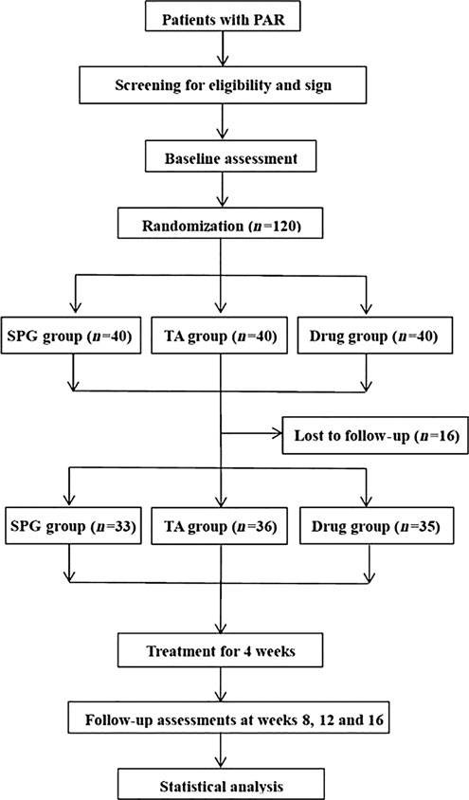
FIG. 1. Flow chart of patient randomization. PAR, persistent allergic rhinitis; SPG group, sphenopalatine ganglion–acupuncture group; TA group, traditional-acupuncture group.
cording to the grouping plan in the envelope. Efficacy was assessed via double-blinded evaluations (i.e., the evaluators were blinded to the patients’ group assignments).

Intervention and Testing Process
SPG-acupuncture group. Bilateral SPG acupoints (SPAs) were determined for each patient. The patient was in a sitting position, and the area of the notch formed by the mandibular coronoid process and the zygomatic process was routinely disinfected. The researcher aligned his or her left index finger with the notch and gently retracted the skin down *1–2 mm from the lower edge of the zygomatic arch to expose the space for acupuncture. The researcher’s right thumb and index finger were used to hold the needle, and the needle tip was directed toward the space described above. The needle (0.3 · 75 mm in length) was inserted into the skin and advanced slowly toward the anterior–superior SPG (adjusting the direction of the needle shaft if necessary) for
*55 mm or until the patient reported a sensation of soreness at the acupuncture point or the upper teeth area (Fig. 2A).

Traditional acupuncture group. Bilateral Yingxiang (LI 20) and Hegu (LI 4) points, and Yintang (Ex-HN 3) points were selected for each patient as acupuncture points according to the Standard of Acupoint Location issued by the State Bureau of Technical Supervision of the People’s Republic of China.¹⁵ The patient was in a sitting position, and after routine disinfection at the acupoints, a 0.3 · 25-mm needle was in- serted into the acupoints and advanced for *16.7 mm or until the patient reported a sensation of soreness at the acupuncture site (Figure 2B–D). All of the patients attended a total of 8 sessions at a frequency of 2 times per week, with 2 weeks per treatment course. An electroacupuncture therapy device (Anyang Xiang Yu Medical Equipment Co., Ltd.) (Fig. 3) was used; each acupuncture point was treated for 30 minutes at 50 Hz at each therapy session.

Drug-treatment group. Budesonide nasal spray (Astra- Zeneca Pharmaceutical Co., Ltd., National Pharmaceutical Standard J20090079, Lot number: MK1243) was selected. The dosage was 1 spray into each nostril, 64 lg per spray, 1 time each in the morning and evening, for 2 weeks per course for a total of 2 courses. No other medications for AR were used during treatment.

Efficacy Evaluations
Symptoms and scores for QoL were assessed and re- corded before treatment and at the end of treatment (i.e., week 4). Follow-up visits were planned at weeks 8, 12, and
16. The visits were scheduled over the telephone and completed within 1 week of the planning timepoint. Symptom changes and QoL among the patients were in- vestigated. The clinical symptoms scoring criteria were as follows: 4 symptoms, including sneezing, runny nose, nasal

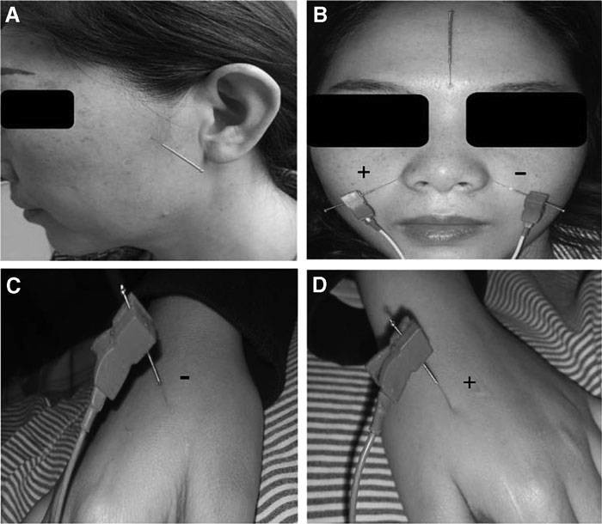
FIG. 2. Acupuncture needle points: (A) sphenopalatine acupoint (SPA), a needling depth of 50 mm and 20 mm applied, is located under the zygomatic arch between the coronoid process and the mandibular condyle. (B) Traditional acupoints: Bilateral Yingxiang (LI 20) and Yintang (Ex-HN 3) (above); (C–D) Bilateral Hegu (LI 4).

congestion, and nasal itching, were scored. Scores of 0, 1, 2, and 3 points corresponded to normal, mild, moderate and severe, respectively, according to the Total Nasal Symptom Score (TNSS). QoL was assessed with the Rhinoconjuncti- vitis Quality of Life Questionnaire (RQLQ).
Downloaded by Kristen Sparrow from www.liebertpub.com at 01/05/20. For personal use only.

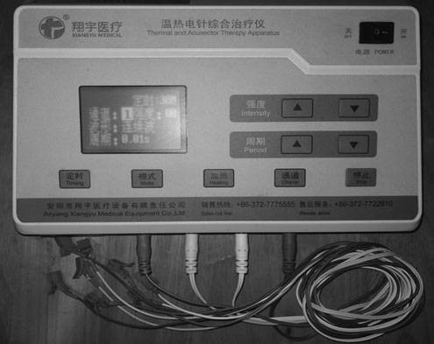
FIG. 3. The electroacupuncture therapy device (Anyang Xiang- Yu Medical Equipment Co., Ltd.; shown with permission). Each acupuncture point was treated for 30 minutes at 50 Hz with a continuous wave during each therapy session.

Safety Evaluations
Adverse events related to acupuncture and drug interven- tions were recorded. In addition, treatment-associated adverse- events management were documented in detail during the study.

Statistical Analysis
The statistical software SPSS 13.0 was used for statistical analysis of all data. Analysis of variance (ANOVA) or the Wilcoxon rank-sum test was used to compare the means among the 3 groups. A paired t-test or the Wilcoxon signed- rank test was used to compare differences before and after treatment in each patient. P < 0.05 was considered statisti- cally significant (P < 0.05/3 = 0.0167 was used for compar- isons among the 3 groups).

RESULTS
Dropouts and Baseline Demographics
A total of 120 participants were randomized and divided into SPG-acupuncture, traditional-acupuncture and drug- treatment group with 40 patients in each group, respectively. Seven (5.83%) patients in the SPG-acupuncture group, 4

Table 1. Baseline Demographic and Clinical Characteristics by Group
Characteristics | SG group (n = 33) | TA group (n = 36) | Drug group (n = 35) | P-value
Age (years) | 36.4 – 10.30 | 37.5 – 10.5 | 38.7 – 11.70 | 0.902
Male/female | 15/18 | 17/19 | 14/21 | 0.867
History of PAR | 55.3 – 16.9 | 41.8 – 19.7 | 45.0 – 22.9 | 0.642
RQLQ | 47.30 – 9.63 | 49.19 – 9.29 | 49.54 – 10.63 | 0.504
TNSS | 8.49 – 1.64 | 8.36 – 1.71 | 8.54 – 1.17 | 0.877
Nasal obstruction | 2.15 – 0.71 | 2.36 – 0.64 | 2.11 – 0.76 | 0.318
Rhinorrhoea | 2.24 – 0.66 | 2.19 – 0.62 | 2.31 – 0.58 | 0.739
Nasal itch | 1.48 – 0.76 | 1.42 – 0.77 | 1.60 – 0.55 | 0.401
Sneezing score | 2.61 – 0.56 | 2.39 – 0.64 | 2.51 – 0.74 | 0.306
Values are expressed as mean – standard deviation unless stated otherwise and tested by an independent t-test. P > 0.05 indicates that there was no statistically significant difference.
SG group, sphenopalatine ganglion group; TA group, traditional acupuncture group; PAR, persistent allergic rhinitis; RQLQ, Rhinoconjunctivitis Quality of Life Questionnaire; TNSS, total nasal symptoms score.

(3.33%) in the traditional-acupuncture group, and 5 (4.17%) in the drug treatment group did not complete the study. The reasons for early discontinuation were similar among the groups. Discontinuations as a result of lost-to-follow-up occurred in 10%, 7.5%, and 7.5% of patients in the SPG- acupuncture, traditional-acupuncture, and drug-treatment groups, respectively. Discontinuations as a result of per- sonal reasons occurred in 7.5% and 2.5% of patients in the SPG acupuncture and traditional-acupuncture groups, respec- tively. In the drug-treatment group, the reasons for treatment discontinuation were that patients could not comply with the instructions for using the medication.
Downloaded by Kristen Sparrow from www.liebertpub.com at 01/05/20. For personal use only.
The groups had similar baseline characteristics (Table 1). No significant differences in age (F = 0.103; P = 0.902), gender (Z = 0.286; P = 0.867) and disease duration (F = 0.451; P = 0.642) were identified. At baseline, the mean scores for individual nasal symptoms, TNSS’, or RQLQ scores were
not different in the SPG-acupuncture, traditional-acupuncture, and drug-treatment groups.

Efficacy
After 4 weeks of treatment, as shown in Figure 4, SPG acupuncture was not superior to traditional acupuncture, with an average effectiveness rate of 78.79% for the SPG group and 61.11% for the traditional-acupuncture group (P = 0.09). Drug treatment was significantly more effective than traditional acupuncture (P = 0.022). Four weeks after treatment ended, the effectiveness rate in the SPG- acupuncture group was superior to that of the traditional- acupuncture group (P = 0.033) but was still lower than that of the drug-treatment group (P = 0.039), with mean effec- tiveness of 69.70%, 44.44%, and 71.43%, respectively. Moreover, this difference persisted for the duration of the study but gradually decreased in each group during weeks 8 through 16.
A supplemental analysis of TNSS’ showed that, on the
day treatment ended, the mean TNSS’ significantly im-
proved after treatment, compared with before treatment (P < 0.05; Fig. 5); mean percentage reductions from baseline were 24.6% for the SPG-acupuncture group, 8.2% for the traditional-acupuncture group, and 39.1% for the drug- treatment group. Furthermore, statistically significant im- provements in TNSS’ and reductions in nasal congestion and sneezing symptoms were observed in the SPG- acupuncture group, compared with the traditional acu- puncture group as early as the day treatment ended, and this continued throughout the observation period (P < 0.05). However, this did not occur for sneezing, during weeks 8 through weeks 12 after treatment ended (Figs. 5 and 6). In addition, there were no significant differences in reductions in symptoms and improvements in TNSS’ between the SGP-acupuncture group and the drug-treatment group at each follow-up timepoint (P > 0.05; Fig. 6).
After 4 weeks of treatment, the RQLQ scores of the 3 groups were significantly lower than those before treatment (P = 0.000) but no differences were found among the groups (P > 0.05). Four weeks later, no significant differences were found between the SPG-acupuncture group and traditional- acupuncture group, or the drug-treatment group (P = 0.182,
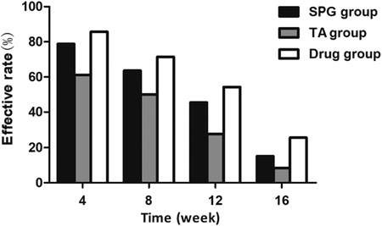
FIG. 4. The effective rate of the treatment group. 4 weeks = the endpoint of the treatment; 8, 12, and 16 weeks = 4, 8, 12 weeks after the treatment; SPG group, sphenopalatine ganglion–acu- puncture group; TA group, traditional-acupuncture group.

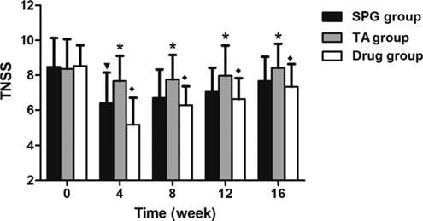the SPG-acupuncture group and the traditional-acupuncture group or the drug-treatment group at week 16 (P = 0.036 and P = 0.635, respectively; Table 2).
Based on these observations, it was concluded that that SPG acupuncture was significantly more effective than traditional acupuncture for reducing mean TNSS’ that in- cluded nasal congestion and sneezing at most timepoints.

FIG. 5. Difference in total nasal symptom score (TNSS). *In- dicates significant difference between the sphenopalatine ganglion (SPG)–acupuncture group and the traditional acupuncture group, P < 0.0167; ^{A}Indicates significant difference between the tradi- tional acupuncture group and the drug-treatment group, P < 0.0167;
;Indicates significant difference between the SPG-acupuncture-
group and drug-treatment group, P < 0.0167. TNSS, total nasal symptom score; TA group, traditional-acupuncture group.

P = 0.263, respectively). At week 12, the RQLQ score of the SPG-acupuncture group was lower than that of the traditional-acupuncture group (P = 0.006) but was not sig- nificantly different from that of the drug-treatment group (P = 0.784). No significant differences were found between

Safety
During the clinical trial, 9 patients experienced transient fainting during the initial treatment but recovered after rest. This symptom did not occur in the subsequent acupuncture treatments. In the traditional-acupuncture group, 4 patients developed local swelling and pain. These symptoms sub- sided after application of ice and disappeared after 2 days. No patients had abnormal vital signs, clinical laboratory test results, or electrocardiograms after treatment.

DISCUSSION

Deciding on an appropriate control procedure for clinical studies on acupuncture is a particular challenge.¹⁴ Many

Downloaded by Kristen Sparrow from www.liebertpub.com at 01/05/20. For personal use only.
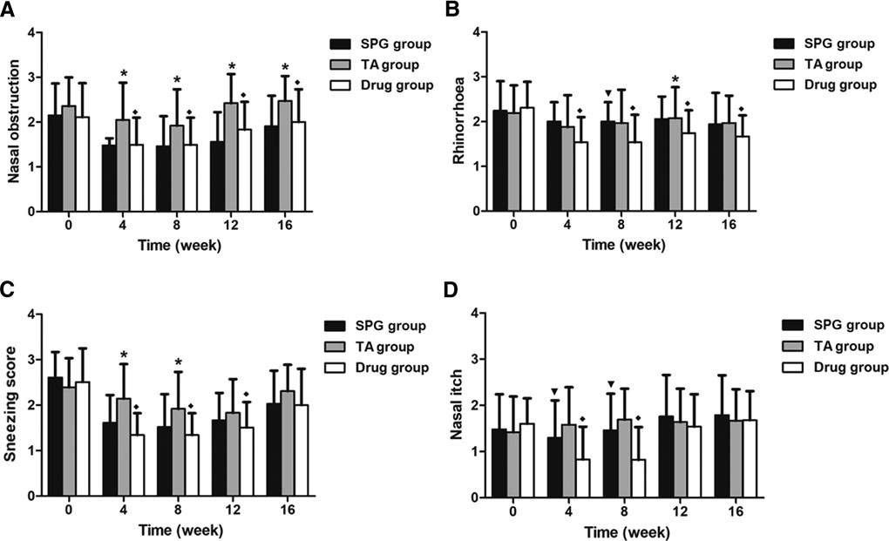
FIG. 6. Changes in nasal symptom scores by treatment group, such as nasal obstruction (A), rhinorrhea (B), sneezing (C), and nasal itching (D). *Indicates significant difference between the sphenopalatine ganglion (SPG)–acupuncture group and the traditional acu- puncture (TA) group, P < 0.0167; ^{A}Indicates significant difference between the TA group and the drug-treatment group, P < 0.0167;
;Indicates significant difference between the SPG-acupuncture group and drug-treatment group, P < 0.0167.

Table 2. Summary of Pre- and Postintervention RQLQ Scores (X – S)
Timepoints SG group (n = 33) TA group (n = 36) Drug treatment group (n = 35) Pª P^{b} P^{c}
0 weeks | 47.30 – 9.63 | 49.19 – 9.29 | 49.54 – 10.63 | 0.358 | 0.872 | 0.365
4 weeks | 32.00 – 13.49 | 32.42 – 10.98 | 26.63 – 9.34 | 0.888 | 0.020 | 0.059
8 weeks | 33.64 – 11.01 | 37.03 – 9.86 | 30.91 – 8.84 | 0.182 | 0.008* | 0.263
12 weeks | 36.88 – 10.11 | 42.83 – 7.02 | 36.25 – 8.50 | 0.006* | 0.001* | 0.784
16 weeks | 42.82 – 10.63 | 47.03 – 6.66 | 41.71 – 8.40 | 0.036 | 0.004* | 0.635
*Indicates significant difference between two groups, P < 0.05/3 = 0.0167.
ROLQ, Rhinoconjunctivitis Quality of Life Questionnaire; SG group, sphenopalatine ganglion group; TA group, traditional acupuncture group; Pª, sphenopalatine ganglion group vs. traditional acupuncture group; P^{b}, traditional acupuncture group vs. drug treatment group; P^{c}, sphenopalatine ganglion group vs. drug treatment group.

studies have previously demonstrated the therapeutic effi- cacy of acupuncture using control groups including repeated measurements before and after treatment, Western medi- cations,¹⁶ placebo acupuncture,¹⁷ and sham acupuncture.¹⁸ A 2016 systematic review concluded that clinical evidence supporting the use of acupuncture at the SPG still remains insufficient due to a lack of large sample-sized, multicenter, randomized controlled trials.¹⁹ Therefore, in the present study, a comparative study of the therapeutic efficacy be- tween acupuncture at the SPG with traditional acupuncture was carried out. In addition, nasal corticosteroids, the first- line treatment agents,²⁰ achieved the best results after a 4- week intranasal hormone therapy trial by Zhang et al.²¹ Accordingly, intranasal hormone application for 4 weeks was used as a positive control in this study to evaluate the therapeutic efficacy of acupuncture objectively. To the current authors’ knowledge, there were no other random- ized, controlled clinical trials in which acupuncture at the SPC was directly compared with other traditional acu- puncture, and that also confirmed SPG-acupuncture’s place further for treating PAR.
Downloaded by Kristen Sparrow from www.liebertpub.com at 01/05/20. For personal use only.
Acupuncture, as an excellent Traditional Chinese Medicine (TCM) approach, has been practiced in China for more than 2000 years to treat various diseases based on the meridian theory as described in the Yellow Emperor’s Classic of Internal Medicine.²² Acupuncture has been shown to be beneficial in several previous studies of al- lergic rhinitis.^{23–25}
In TCM, energy (Qi) flows throughout the body through meridians. Acupoints, distributed along the meridian chan- nels,²⁶ are not only projection points of diseases but also are stimulation points for acupuncture treatment. From a mod- ern viewpoint, they are also areas where nerve terminals and nerve stems pass. The nose is in the utmost Yang position of the Yang, where the Qing Yang meets. The meridians in the nose and around the nose are mostly Yang meridians. Fur- thermore, the traditional acupoints selected in this study were located around the nose and are easy to access. The Yingxiang (LI 20) and Yintang (Ex-HN 3) acupoints are close to the nose, while the Hegu (LI 4) acupoint is far from it. Modern research has shown that both LI-4 and other acupoints in the facial area connect to the nucleus of the
solitary tract via direct or indirect fibers, which might be the morphologic basis for the treatment of facial disease at the (LI 4) acupoint.²⁷ A large number of clinical studies have fully proved the therapeutic efficacy and safety of tradi- tional acupoints above-mentioned in the treatment of AR; thereby, these points served as clinical control acupoints in the current study.
The SPA, a more-recently discovered acupoint used in the treatment of nasal disease, is different from the tradi- tional acupoint in that it is a single acupoint rather than a grouped acupoint. The common SPA, placed below the zygomatic arch, is located between the condyle and cor- onoid process of the mandible. The needle is directed to- ward the anterior superior medial side, with a depth of
  - mm. The distance from the corresponding puncture point to the horizontal line is 33 mm, while the distance to the perpendicular line through the lateral canthus is 42 mm, thereby indicating a constant body surface marker. Li called this point ‘‘treating nasal disease 3,’’²⁸ and Zhang et al. called this point the Die-e acupoint.²⁹An experimental an- atomical study of cadaveric heads by Zhang et al. showed that blind stimulation of the SPG using a filiform needle through the infraorbital fossa is feasible.³⁰ In addition, the oral approach has also been used to stimulate the SPG.³¹ However, the SPG point should be used with caution due to an increased risk of infection and poor patient cooperation. Therefore, the current study used a lateral approach to in- sert the needle, which is considered easy to perform based on the associated anatomical markers, and this is worth recommending.
In the present study, 4 weeks after treatment ended, the effectiveness rate in the SPG-acupuncture group was superior to that of the traditional acupuncture group (P = 0.033; Fig 1), and this difference was maintained throughout the duration of the study. Moreover, acupuncture at the SPG was well- tolerated, with no serious adverse events. The results of this current study are consistent with the results of previous studies of acupuncture in patients with PAR, in which acu- puncture provided rapid and sustained relief of rhinitis symptoms and was well-tolerated.²⁴
PAR is a symptomatic nasal disorder, characterized by chronic nasal symptoms of nasal itching, sneezing, nasal

congestion, and rhinorrhea.³² In the present study, throughout the observation period, a greater decrease with SPG acupuncture than with traditional acupuncture oc- curred only in 2 of these symptoms—sneezing and nasal congestion—but not for sneezing during weeks 8 through weeks 12 after treatment ended (Figs. 2 and 3). However, the reductions in TNSS (total score for the 4 individual symptoms) was greater with SPG acupuncture, thus adding to the small body of evidence currently supporting the ef- ficacy of acupuncture at the SPG being superior to tradi- tional acupuncture for treating this disorder.
Downloaded by Kristen Sparrow from www.liebertpub.com at 01/05/20. For personal use only.
Although numerous studies have shown positive out- comes for acupuncture treating AR,^{23–25} the exact molec- ular mechanisms of action of acupuncture are yet to be elucidated. Acupuncture has been reported to inhibit syn- thesis of cytokines, such as interleukin-10,³³ in patients with AR. Moreover, acupuncture also affects cellular immunity by improving blood microcirculation³⁴ or regulating CD3 and CD4 T-cells,³⁵ as well as stimulating release of neu- ropeptides involved in neurogenic inflammation, such as substance P and beta-endorphin.³⁶ In addition, Lu et al.³⁷ demonstrated that acupuncture at the SPG can also reduce nasal-gland secretion, capillary permeability, and sensory hypersensitivity to achieve therapeutic effects. Determining the nature and mechanisms of the increased synthesis of neurosecretory factors involved in acupuncture at SPG- mediated therapeutic efficacy is obviously a challenge for all researchers in the field.

CONCLUSIONS

Acupuncture at the SPG is effective and safe for treating PAR. This acupuncture reduces nasal symptoms rapidly and improves rhinoconjunctivitis QoL questionnaire scores, and its effects do not disappear 12 weeks after treatment ends.

ACKNOWLEDGMENTS

The authors acknowledge the help from Shengqiao Li, PhD, who is from the department of Traditional Chinese Medicine at The 5th Affiliated Hospital of Sun Yat-Sen University, for his assistance in editing and proofreading the manuscript for this article.

AUTHORS’ CONTRIBUTIONS

Jiao-Ping Mi performed the statistical analysis, drafted the manuscript, designed the study, and revised the manu- script later. Peng He designed the study and performed the acupuncture; some of the study results were incorporated into his thesis. Xuan Yang performed the acupuncture. Fang Shen and Miao-Feng Zhao performed the house dust-mite
test and blood tests at the department of clinical laboratory. Miao-Feng Zhao and Xin-Ye Chen participated in patient recruitment and assessment at the department of ear-nose- and-throat. Xin-Ye Chen initiated the project, participated in its design and coordination, and drafted the manuscript for this article. All authors read and approved the final version of the manuscript for this article.

AUTHOR DISCLOSURE STATEMENT
No competing financial interests exist.

FUNDING INFORMATION

This study was supported by a grant from the Zhuhai Scientific and Technological Project Fund and Guangdong administration of Traditional Chinese Medicine Project Fund (Number: 20181117E030007,20191072).

REFERENCES

    - Wang Y, Chen H, Zhu R, et al. Allergic rhinitis control test questionnaire–driven stepwise strategy to improve allergic rhinitis control: A prospective study. Allergy. 2016;71(11): 1612–1619.
    - Australian Bureau of Statistics (ABS). National Health Sur- vey: Summary of Results 2004–2005. Canberra: ABS; 2006.
    - Sundman E, Olofsson PS. Neural control of the immune system. Adv Physiol Educ. 2014;38(2):135–139.
    - Sarin S, Undem B, Sanico A, Togias A. The role of the nervous system in rhinitis. J Allergy Clin Immunol. 2006; 118(5):999–1016.
    - Zhang Z, Yang X, Yang X. Clinical efficacy and prognosis of Yi-shou acupuncture therapy combined with clopidogrel on moderate–severe intermittent allergic rhinitis. Chongqing Med. 2016;45(25):3542–3544.
    - Yong R, Wu L, Jin Z. Therapeutic observation of immediate effect and long-term efficacy of nasal cavity penetration needling on allergic rhinitis. J Clin Acupunct Moxibustion. 2016;32(7):9–12.
    - Adam D, Grabenhenrich L, Ortiz M, Binting S, Reinhold T, Brinkhaus B. Impact of acupuncture on antihistamine use in patients suffering seasonal allergic rhinitis: Secondary anal- ysis of results from a randomised controlled trial. Acupunct Med. 2018;36(3):139–145.
    - Seidman MD, Gurgel RK, Lin SY, et al. Clinical practice guideline: Allergic rhinitis executive summary. Otolaryngol Head Neck Surg. 2015;152(2):197–206.
    - Cheng L, Chen J, Fu Q, et al. Chinese Society of Allergy Guidelines for Diagnosis and Treatment of Allergic Rhinitis. Allergy Asthma Immunol Res. 2018;10(4):300–353.
    - McDonald JL, Cripps AW, Smith PK, Smith CA, Xue CC, Golianu B. The anti-inflammatory effects of acupuncture and their relevance to allergic rhinitis: A narrative review and proposed model. Evid Based Complement Alternat Med 2013; 2013:591796.

    - Li XW, Tian ZP. A preliminary summary of the treatment on rhinitis puncturing sphenopalatine ganglion. Beijing Chin Med. 1990;9(12):36–38.
Downloaded by Kristen Sparrow from www.liebertpub.com at 01/05/20. For personal use only.
    - Wang K, Chen L, Wang Y, Wang C, Zhang L. Sphenopala- tine ganglion acupuncture improves nasal ventilation and modulates autonomic nervous activity in healthy volunteers: A randomized controlled study. Sci Rep. 2016;6:29947.
    - Mi JP, Chen X, Lin X, Guo J, Chen H, Wei L, Hong H. Treatment of persistent allergic rhinitis via acupuncture at the sphenopalatine acupoint: A randomized controlled trial. Trials. 2018;19(1):28.
    - Subspecialty Group of Rhinology, Editorial Board of Chinese Journal of Otolaryngology, Head and Neck Surgery; Sub- specialty Group of Rhinology, Society of Otolaryngology, Head and Neck Surgery, Chinese Medical Association. Guidelines for the Diagnosis and Treatment of Allergic Rhinitis (Tianjin conference, 2015) [in Chinese]. Chin J Otorhinolar- yngol Head Neck Surg. 2016;(51):6–24.
    - Huang LX, Zhao JS, Wu ZC, et al. [Editorial explanation on the state standard The Name and Location of Acupoints (2006, edition)] [in Chinese]. Zhongguo Zhen Jiu. 2009; 29(11):924–926.
    - Birch S. Clinical research on acupuncture: Part 2. Controlled clinical trials, an overview of their methods. J Altern Com- plement Med. 2004;10(3):481–498.
    - Kaptchuk TJ, Stason WB, Davis RB, et al. Sham device v inert pill: Randomised controlled trial of two placebo treat- ments. BMJ. 2006;332(7538):391–397.
    - Dincer F, Linde K. Sham interventions in randomized clinical trials of acupuncture—a review. Complement Ther Med. 2003;11(4):235–242.
    - Chen L, Zhang L, Mao W, et al. Evaluation on allergic rhi- nitis treated by sphenopalatine ganglion stimulation with acupuncture: A systematic review. Int J Tradit Chin Med. 2016;38:254–260.
    - Wheatley LM, Togias A. Clinical practice: Allergic rhinitis. N Engl J Med. 2015;372(5):456–463.
    - Zhang L, Xu G, Wang XD, et al. Treatment of allergic rhinitis with nasal mometasone furoate [in Chinese]. Chin J Otorhi- nolaryngol Head Neck Surg. 2009;44(6):455–459.
    - Veith I. The Yellow Emperor’s Classic of Internal Medicine. Bulletin of the Medical Library Association. 1968;12(4):425– 425.
    - Xue CC, English R, Zhang JJ, Da Costa C, Li CG. Effect of acupuncture in the treatment of seasonal allergic rhinitis: A randomized controlled clinical trial. Am J Chin Med. 2002; 30(1):1–11.
    - Ng DK, Chow PY, Ming SP, et al. A double-blind, random- ized, placebo-controlled trial of acupuncture for the treatment of childhood persistent allergic rhinitis. Pediatrics. 2004; 114(5):1242–1247.
    - Brinkhaus B, Hummelsberger J, Kohnen R, et al. Acupuncture and Chinese herbal medicine in the treatment of patients with seasonal allergic rhinitis: A randomized–controlled clinical trial. Allergy. 2004;59(9):953–960.
    - Yung KT. A birdcage model for the Chinese meridian system: Part I. A channel as a transmission line. Am J Chin Med. 2004;32(5):815–828.
    - Chen S, Jin Z, Jing X, et al. Morphological study on the afferent pathways of the ‘‘Hegu’’ point and mouth–face re- gion. Acupunct Res. 2004;29:217–221.
    - Li X. Acupuncture of the sphenopalatine ganglion—mech- anism analysis of the introduction of acupuncture methods for ‘‘treating nasal disease 3’’ acupoints in the treatment of nasal diseases. J Clin Otorhinolaryngol Head Neck Surg. 2011; 25(5):193–196.
    - Zhang W, Wang Z, Wu B. Anatomic study on sphenopalatine ganglion by puncturing three acupoints. J Fujian Coll Tradit Chin Med. 2007;17(56):39–42.
    - Zhang L, Fang D, Jiang D, Xu Z, Guo M, Chen, L Lin P. Feasibility and safety assessment of the fossa infratemporalis approach for blind-needle at sphenopalatine ganglion [in Chinese]. Chin Acupunct Moxibustion. 2016;36(11):1171– 1176.
    - Sun B. Treatment of allergic rhinitis by blocking the sphe- nopalatine ganglion with triamcinolone acetonide injection through the mouth cavity: A report of 415 cases. J Preclin Med Coll Shangdong University. 2004;18(6):342–343.
    - Broz_ ek JL, Bousquet J, Agache I, et al. Allergic rhinitis and its impact on asthma (ARIA) guidelines—2016 revision. J Allergy Clin Immunol. 2017;140(4):950–958.
    - Petti FB, Liguori A, Ippoliti F. Study on cytokines IL-2, IL-6, IL-10 in patients of [sic] chronic allergic rhinitis treated with acupuncture. J Tradit Chin Med. 2002;22(2):104–111.
    - Zhang YQ. Clinical experience in acupuncture treatment of allergic rhinitis. J Tradit Chin Med. 2009;29(3):186– 189.
    - Joos S, Schott C, Zou H, Daniel V, Martin E. Immunomo- dulatory effects of acupuncture in the treatment of allergic asthma: A randomized controlled study. J Altern Complement Med. 2000;6(6):519–525.
    - Dawidson I, Angmar-Maˆnsson B, Blom M, Theodorsson E, Lundeberg T. Sensory stimulation (acupuncture) in- creases the release of calcitonin gene–related peptide in the saliva of xerostomia sufferers. Neuropeptides. 1999;33(3): 244–250.
    - Lu J, Tai H. Treating 20 cases of rhinallergosis by acu- puncting sphenopalatine ganglion through Quanliao Xiaguan. J Gansu Coll Tradit Chin Med. 2000;17(4):30–32.

Address correspondence to:
Xin-Ye Chen, MD
Department of Otolaryngology Head and Neck Surgery The 5th Affiliated Hospital of Sun Yat-Sen University
Yat-Sen University, Meihua Road 52
Zhuhai 519000
China E-mail: chenxy850547@163.com

