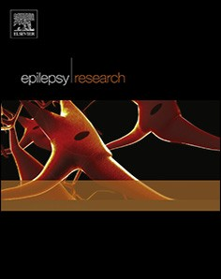
EpilepsyResearch153(2019)83–84
Contents lists available at ScienceDirect

Epilepsy Research
journal homepage: www.elsevier.com/locate/epilepsyres

Lessons learned from transcutaneous vagus nerve stimulation (tVNS)
Hajo M. Hamerª, Sebastian Bauer^{b,⁎}
a Epilepsy Center Erlangen, Dept. of Neurology, University of Erlangen, Germany
b Epilepsy Center Frankfurt Rhine-Main, Dept. of Neurology, University of Frankfurt, Germany

A R T I C L E I N F O

Keywords:
Transcutaneous vagus nerve stimulation Epilepsy
Seizures Treatment
A B S T R A C T

Transcutaneous vagus nerve stimulation (tVNS) is a newly developed method which intends to overcome the disadvantage of surgical implantation of the stimulation device. The tVNS device is designed to stimulate the auricular branch of the vagus nerve via a bipolar electrode attached to the skin of the left ear conch. A ran- domized, double-blind controlled trial assessed eﬃcacy and safety over 20 weeks of tVNS (n=39) vs. active control tVNS (n=37) in patients with drug-resistant epilepsy. While the mean seizure reduction per 28 days at end of treatment (2.9% reduction from baseline in the control group vs 23.4% in the active group) did not reach statistical signiﬁcance, there was a signiﬁcant reduction in seizure frequency (34 %) in patients in the tVNS group at the end of the treatment period (20 weeks). TVNS was well-tolerated. The results justify further trials with longer observation periods and possibly at earlier stages of epilepsy.

- Introduction and rationale for development

Various brain stimulation therapies are currently available. VNS is the stimulation method which is most frequently applied and is asso- ciated with the longest experience in clinical practice. It requires im- plantation of a stimulator and an electrode which connects to the left vagal nerve. Long-term VNS reduced seizure frequency during initial treatment by roughly 30%–40% (Handforth et al., 1998; Morris and Mueller, 1999). The treatment eﬀect usually increases over time (Morris and Mueller, 1999). Transcutaneous vagus nerve stimulation (tVNS) is a newly developed method which intends to overcome the disadvantage of surgical implantation of the stimulation device.

- Technical and functional characteristics

The auricular branch of the vagus nerve supplies the cymba conchae (Peuker and Filler, 2002). It can be stimulated using an external device with a bipolar electrode attached to the skin of the left ear conch (Fig. 1). Typical settings are: stimulation frequency 25 Hz, pulse width
250 μs, 30 s on/30 s oﬀ, application time 4 h per day, resulting in
180.000 stimuli per day. Active control stimulation can be performed with 1 Hz, resulting in 7.200 stimuli per day. Pilot studies showed re- sponder rates and mean seizure reduction of up to 55% (Stefan et al., 2012; He et al., 2013).

- Results

One randomized, double-blind controlled trial has been performed to assess eﬃcacy and safety over 20 weeks of tVNS in patients with drug-resistant epilepsy (Bauer et al., 2016). Primary objective was to demonstrate superiority of add-on therapy with tVNS (stimulation fre- quency 25 Hz, n = 39) versus active controls (1 Hz, n = 37) in reducing seizure frequency over 20 weeks. The primary eﬃcacy variable was the relative change of seizure-frequency per 28 days over the treatment period. Analysis of covariance (ANCOVA) was performed with treat- ment as factor and baseline seizure frequency per 28 days as covariate, calculating treatment diﬀerences in least square means and 95% con- ﬁdence intervals. Responder rates were compared between the two treatment groups using a logistic regression model with treatment as factor and the log-transformed baseline seizure-frequency per 28 days as covariate.
With treatment adherence of > 80% in both groups, the diﬀerence
in mean seizure reduction per 28 days at end of treatment (2.9% re- duction from baseline in the 1 Hz group vs 23.4% in the 25 Hz group) was not signiﬁcant (p = 0.146). However, there was a signiﬁcant re- duction in seizure frequency in patients in the 25 Hz group at the end of the treatment period, i.e. at 20 weeks (n = 26, 34.2%, p = 0.034) (Fig. 2).
Responder rates (25%, 50%) were similar in both groups (Fig. 3). The study failed to show superiority of 25 Hz tVNS over 1 Hz tVNS

⁎ Corresponding author at: Epilepsy Center Frankfurt Rhine-Main, Universitaetsklinikum Frankfurt, Klinik fuer Neurologie, Goethe-Universitaet Frankfurt, Schleusenweg 2-16, 60528 Frankfurt, Germany.
E-mail address: S.Bauer@med.uni-frankfurt.de (S. Bauer).

https://doi.org/10.1016/j.eplepsyres.2019.02.015
Availableonline26February2019
Received 28 December 2018; Received in revised form 25 February 2019; Accepted 25 February 2019

0920-1211/©2019PublishedbyElsevierB.V.

H.M. Hamer and S. Bauer EpilepsyResearch153(2019)83–84
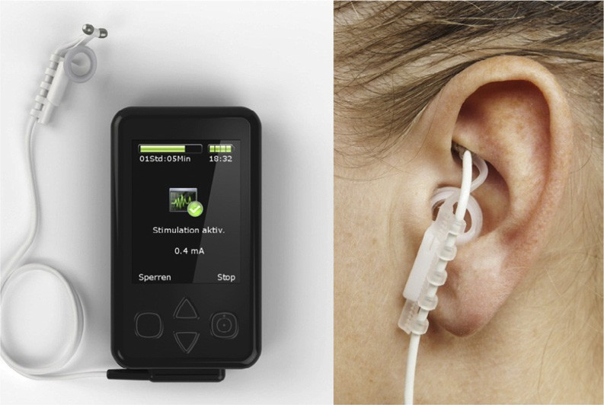
moderate but signiﬁcant seizure reduction rate of 23.4% within the 25 Hz per-protocol group.

- Tolerability and safety

Adverse events were usually mild or moderate and comprised headache (1 Hz: 35.9%; 25 Hz:32.4%), ear pain 1 Hz: 7.7%, 25 Hz: 16.2%), application site erythema (1 Hz:2.6%; 25 Hz: 8.1%), vertigo (1 Hz: 7.7%; 25 Hz: 10.8%), fatigue (1 Hz: 12.8%; 25 Hz: 2.7%), and
nausea (1 Hz: 7.7%; 25 Hz: 8.1%). One sudden unexplained death in epilepsy (SUDEP) occurred in the 1 Hz group.

Fig. 1. tVNS device NEMOS®. Left side: programmable stimulation device and ear electrode. Right side: placement of ear electrode in the ear conch; taken from (Bauer et al., 2016).
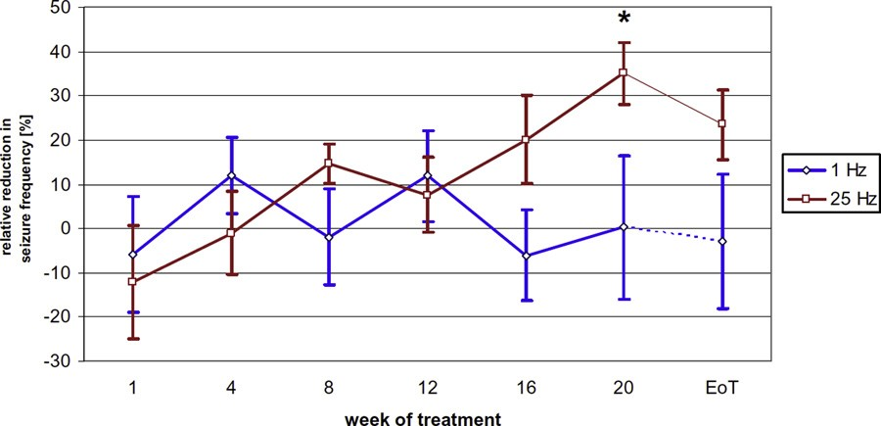
Fig. 2. Mean relative reduction in seizure frequency at each study visit as compared to baseline seizure frequency. LS-means, *p < 0.05. Error bars: SEM; taken from (Bauer et al., 2016).
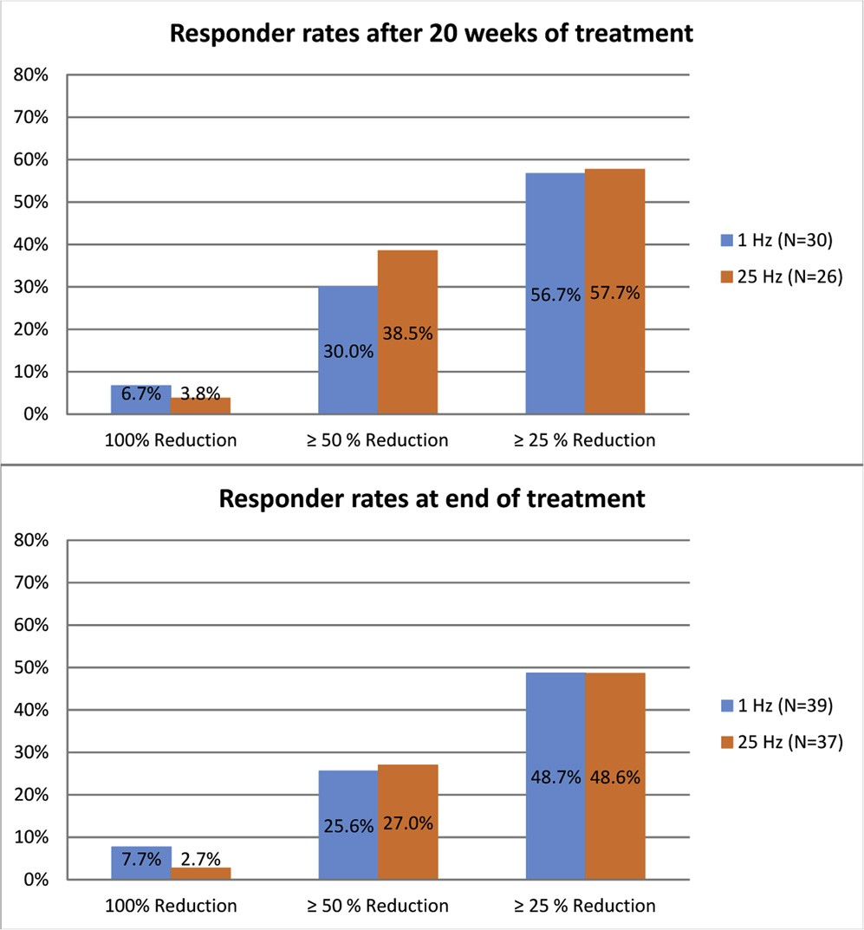
Fig. 3. Responder rates after 20 weeks of tVNS treatment and at end of treat- ment (including patients who did not complete the full 20 weeks of treatment).

in the intention-to-treat study population. However, there was a

- Further studies

The results justify further trials in larger patient populations. The following lessons have to be learnt:

Since treatment eﬀect appeared to increase after 20 weeks of treatment, longer observation periods are necessary when assessing potential neuromodulatory eﬀects.
•
•
Future trials should include comparisons of tVNS and standard VNS: patients who beneﬁted from tVNS treatment could be considered for implantation of standard or responsive VNS. Positive responses to tVNS could allow personalization of neuromodulatory treatments, while negative responses could avoid unnecessary implantations. Due to its favorable safety proﬁle and non-invasive nature, tVNS in contrast to VNS, could be considered for treatment studies at early stages of epilepsy.
•
•
Because numerous parameters of brain stimulation therapies (e. g. stimulation target, frequency, pulse patterns, intensity, duration) can be adjusted within wide ranges, the “optimal” stimulation set- tings remain unclear. Hence, there is a strong need for comparative studies.

In conclusion, the clinical value of tVNS cannot be ﬁnally evaluated at this point and the results of further trials must be awaited (Boon et al., 2018).

References

Bauer, S., Baier, H., Baumgartner, C., Bohlmann, K., Fauser, S., Graf, W., Hillenbrand, B., Hirsch, M., Last, C., Lerche, H., Mayer, T., Schulze-Bonhage, A., Steinhoﬀ, B.J., Weber, Y., Hartlep, A., Rosenow, F., Hamer, H.M., 2016. Transcutaneous vagus nerve stimulation (tVNS) for treatment of drug-resistant epilepsy: a randomized, double- blind clinical trial (cMPsE02). Brain Stimul. 9, 356–363.
Boon, P., De Cock, E., Mertens, A., Trinka, E., 2018. Neurostimulation for drug-resistant epilepsy: a systematic review of clinical evidence for eﬃcacy, safety, contra- indications and predictors for response. Curr. Opin. Neurol. 31, 198–210.
Handforth, A., DeGiorgio, C.M., Schachter, S.C., Uthman, B.M., Naritoku, D.K., Tecoma, E.S., Henry, T.R., Collins, S.D., Vaughn, B.V., Gilmartin, R.C., Labar, D.R., Morris,
G.L., Salinsky, M.C., Osorio, I., Ristanovic, R.K., Labiner, D.M., Jones, J.C., Murphy, J.V., Ney, G.C., Wheless, J.W., 1998. Vagus nerve stimulation therapy for partial- onset seizures. A randomized active-control trial. Neurology 51, 48–55.
He, W., Jing, X., Wang, X., Rong, P., Li, L., Shi, H., Shang, H., Wang, Y., Zhang, J., Zhu, B., 2013. Transcutaneous auricular vagus nerve stimulation as a complementary therapy for pediatric epilepsy: a pilot trial. Epilepsy Behav. 28, 343–346.
Morris 3rd., G.L., Mueller, W.M., 1999. Long-term treatment with vagus nerve stimulation in patients with refractory epilepsy. The Vagus Nerve Stimulation Study Group E01- E05. Neurology 53, 1731–1735.
Peuker, E.T., Filler, T.J., 2002. The nerve supply of the human auricle. Clin. Anat. 15,
35–37.
Stefan, H., Kreiselmeyer, G., Kerling, F., Kurzbuch, K., Rauch, C., Heers, M., Kasper, B.S., Hammen, T., Rzonsa, M., Pauli, E., Ellrich, J., Graf, W., Hopfengartner, R., 2012.
Transcutaneous vagus nerve stimulation (t-VNS) in pharmacoresistant epilepsies: a proof of concept trial. Epilepsia 53, e115–118.

84

